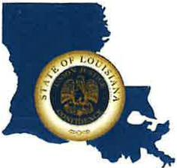 | CAPITAL AREA GROUNDWATER CONSERVATION DISTRICT
GARY I. BEARD
EXECUTIVE DIRECTOR

MEETING NOTICE
Capital Area Groundwater Conservation District
Administrative Committee Meeting

WHEN: Wednesday, December 14, 2022

TIME: 10:30 a.m.

WHERE: Renaissance Hotel
7000 Bluebonnet Blvd.
Baton Rouge, LA 70809

Contact Person: Lisa Manda, (225) 293-7370

